2020 Orange Scholars Scholarship Program

Program Overview
- Who is eligible to apply?
- When is the application deadline?
- What is the Program timeline?
- Is this award renewable?
- Who administers this Program?

Application Details
- Which school should I list on the application if I have not made a final decision?
- My parent’s employment makes me eligible for this scholarship. Whose contact information should I include?
- What is the difference between Official and Unofficial Transcripts?
- What supporting documentation is required for this application if I am named as a semi-finalist?
- Where and when should I send my supporting documents?

Upload FAQs
- What should be visible on my documents?
- What are the acceptable file types?
- Why can’t I upload a Word document?
- One of the documents I uploaded has a status of Rejected. What do I do now?
- How do I upload more than one file at a time?
- How to I create a .zip file?
- How long does it take to process my uploaded documents?
- The deadline has passed, and my documents are still Processing, what does that mean?
- What are the DOs and DON’Ts of uploading documents to my application?

Notifications
- How will I be notified about the status of my application?
- What notifications will be sent to me?
- Who will notifications be sent from?
- When will I receive notifications?
- Can I opt out of notifications?

Application Status
- How do I know if my application is Complete?
- As the applicant, what are my responsibilities?
- How do I use my Home page to verify my application status?
- The deadline is tomorrow, and it takes 5-7 days to process. Will I make it?
- The deadline has passed, and my application status is Started, what do I do?

Award Details
- What are the selection criteria?
- What are the details of the award?
- What are my responsibilities if I am chosen as a recipient?
- How and when are funds issued?
- How do I change my college choice?

Other Important Information
- Are scholarships taxable?
- ISTS Self Help Portal
- Contact Information

Home Page Tutorial
- Help & My Profile
- How to Apply
- Application Status

Program Overview

Who is eligible to apply?
Applicants must meet all of the following criteria to be eligible for this scholarship:

You must be a high school senior, college freshman, college sophomore, or college junior planning to enroll as a full-time undergraduate student in the fall of 2020.

You must be a dependent of a full- or part-time hourly associate of The Home Depot and its subsidiaries, The Home Depot Canada, or The Home Depot Mexico at the time of application.

Winners from the 2017, 2018, and 2019 programs may apply regardless of status.

Your parent/guardian must have been employed by The Home Depot for at least one year as of November 1, 2019.

Your parent/guardian must be employed with The Home Depot at the time awards are announced.

If an associate has several children who are eligible for the award, all eligible children may apply. Each child must apply separately and their applications will be judged individually.

When is the application deadline?
January 22, 2020 at 11:59 p.m. Pacific Time Zone – There will be no exceptions.

What is the Program timeline?
- Application Opens: November 1, 2019
- Application Deadline: January 22, 2020
- Semi Finalist Opens: February 3, 2020
- Semi Finalist Deadline: March 2, 2020
- Scholarship Recipients Notified: May 2020
- Scholarship Checks Issued (USA and Canada): July 2020
- Scholarship Wires Sent (Mexico Only): August 2020

Is this award renewable?
No, however, students may reapply each year as long as they continue to meet the eligibility criteria.

Who administers this Program?
To ensure complete impartiality in the selection of recipients and to maintain a high level of professionalism and security, the program is administered by International Scholarship and Tuition Services, Inc. (ISTS), a firm that specializes in managing sponsored scholarship, grant, tuition assistance, and tuition reimbursement programs.

Application Details

Which school should I list on the application if I have not made a final decision?
You should list your first-choice school on the application. You can change your college choice anytime prior to the application period. If selected as a recipient, you will be asked to confirm your final school choice. If your school changes after the acceptance period, you will be able to update this information on your My Profile page.

My parent’s employment makes me eligible for this scholarship. Whose contact information should I include?
You, the applicant, must register for an account with a personal email address. Do not use a parent’s work email address. Your My Profile page should reflect your legal name and contact information. If your parent’s information is needed, it will be specifically asked for on the application.

What are the differences between Official and Unofficial Transcripts?

Official transcripts must be obtained through your high school administration office, or your college registrar office. Transcripts are normally printed on official letterhead and/or state that they are official. Transcripts may contain or require a signature.
Note: Your official transcript may come to you in a sealed envelope, stating it will become unofficial if opened. When scanning or copying your official transcripts, a watermark may appear noting that they are now unofficial. Despite any watermarks or sealed envelopes, you may open the envelope if needed to upload the document. These documents will be considered official for our purposes. Acceptable file types are .pdf, .tif, .png, .jpeg, .jpg, .bmp and .xps. When scanning or copying, you do not need to include a copy of the sealed envelope.

Unofficial transcripts may be accessed through your school’s online student portal. These pages must still be converted to one of the acceptable file formats. Unofficial transcripts must contain your name.

What supporting documentation is required for this application if I am named as a semi-finalist?
- High School/Secondary School Transcript: College Freshman, First Year University Students, College Sophomores, and pre-university CÉGÉP First Year Students only.
- College/University Transcript: College Sophomores, Second Year University Students, College Juniors, Third Year University Students, College Seniors, Fourth Year University Students, and pre-university CÉGÉP Second Year Students only.
- 2018 or 2019 Tax Form 1040 (Top Two Pages Only): All US Semi-Finalists
- 2018 or 2019 Canadian T1 (Top Three Pages Only): All Canada Semi-Finalists
- 2018 or 2019 Official Monthly Income Documents Receipts: All Mexico Semi-Finalists

Where and when should I send my supporting documents?
All required supporting documents must be uploaded to your online application by the application deadline. If you do not follow the upload instructions exactly, your application may remain incomplete. Documents that meet the criteria required for this application that are uploaded by the deadline will be processed and considered on time.

Upload FAQs

What should be visible on my documents?
All uploaded documents must show your name. If you are using an online portal to access your required documentation and all that is visible is the salutation and your first name (Example: Welcome Joe!), this will meet the name requirement.

What are the acceptable file types?
The only acceptable file types are .pdf, .tif, .png, .jpeg, .jpg, .bmp and .xps. Any other formats will not be reviewed, and your application will remain incomplete. You may upload multiple files within a .zip file. All files within a .zip file must be in one of the acceptable file types listed above.

Why can’t I upload a Word document?
ISTS does not accept any file format that is editable.

One of the documents I uploaded has a status of Rejected. What do I do now?
Review the reason your document was rejected. Once you have corrected that issue, upload a new copy of your document.

How do I upload more than one file at a time?
You may create a .zip file containing more than one file as long as everything included is in an acceptable file type of .pdf, .tif, .png, .jpeg, .jpg, .bmp and .xps. Do not upload additional documentation that is not requested. It will not be reviewed.

How do I create a .zip file?
To use this format, follow the steps outlined below:
- Create a new folder on your Desktop, name it the document type you will be uploading. For example, Test Scores, Transcript, or Financial Documentation.
- Move all the files you wish to upload into the new folder.
- Right click on the folder from your Desktop:
  - PC Users: select “Send to,” followed by “Compressed (zipped) folder.”
  - Mac Users: select “Compress [folder name].”
- Your new .zip file will be located on your Desktop, ready to upload.

How long does it take to process my uploaded documents?
Documents are processed daily. Your document will be processed within five (5) to seven (7) business days. If your document was uploaded prior to the deadline, it will be considered. However, it is your responsibility to monitor your Home page to ensure your document is Accepted.

The deadline has passed, and my documents are still Processing, what does that mean?
All documents must be reviewed for the required information and for accuracy. All documents uploaded prior to the application deadline will be reviewed and considered. It is your responsibility to monitor your Home page to ensure your document is Accepted, and that your application status reads Complete.

What are the DOs and DON’Ts of uploading documents to my application?

DO:
- Upload one of the accepted file types.
- Only upload the requested and required documents.
- Black out any Social Security Numbers. This is not required, but highly advised.
- Return to your Home page to verify your documents have been Accepted.

DON’T:
- Upload a Microsoft® Word document (.doc, .docx) or any other format we don’t accept.
- Upload more than the requested documentation.
- Assume your documents are correct and accepted once you have uploaded them.
- Upload a document stating you are mailing your documents.
- Assume the required document does not pertain to you. If the application states the document is required, your application will remain incomplete if you do not provide that document. Contact us if you are having trouble providing a required document.
- Password protect your uploaded documents. Password protected documents will be rejected.
- Upload any file that has a viewing expiration date.

Notifications

How will I be notified about the status of my application?
Notifications are sent primarily via email to the email you used to create your account. Some programs offer text and voice notifications. Ultimately, it is your responsibility as the applicant to verify your application status on your Home page is Complete.

What notifications will be sent to me?
- Deadline Reminders: Deadline reminder emails are typically sent two (2) weeks and one (1) week prior to the application deadline.
- Selection Results: Selection results notifications are sent to all Complete applicants. This includes semi-finalist and finalist notifications.
- Funds Disbursed: Once your funds have been issued, you will be notified.
- Other Scholarships: Occasionally, if you meet the requirements for another scholarship administered by ISTS, you will be notified. These notifications are not guaranteed.
Your information is never sold to any third party for marketing purposes.

Who will notifications be sent from?
You will receive notifications from two (2) possible ISTS email addresses: donotreply@applyISTS.com and orangescholars@applyISTS.com. You should add both of these email addresses to your “safe senders list” to ensure important emails are not sent to your spam or junk folder.

When will I receive notifications?
Notifications vary by program based on the Program timeline. Refer to the Program timeline listed above for more specific information. Typically, deadline reminders are sent two (2) and one (1) week prior to the application deadline.

Can I opt out of notifications?
While you can opt out of notifications, this is not advised. It is your responsibility as the applicant to ensure your application is Complete. If you opt out of notifications, you will not receive deadline reminders or selection results. Your information is never sold to any third party. The only emails you will receive from ISTS are directly related to your application and, possibly, other scholarship opportunities.

Application Status

How do I know if my application is Complete?
Complete applications will have a green COMPLETE button, as shown below:

If your application status has a grey or orange STARTED button as shown below, click the button to view the status of each individual requirement.

As the applicant, what are my responsibilities?
It is your responsibility to make sure your application is Complete. Your online application form must be Submitted, all required documents uploaded and Accepted, and all required supplements must be Complete.

How do I use my Home page to verify my application status?
When you log in to your Home page, you will see all applications listed. Each application will have an overall status button visible to you.

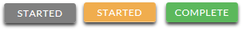

A grey STARTED button means you have not submitted your online form. An orange STARTED button means you have submitted the online form but you are either missing required items for the application, or your documents are still processing.

When you click the status button, you will see the more detailed status. This will show you the status of each individual required portion of the application. For more details on your Home page, review the Home Page Tutorial section.

The deadline is tomorrow and it takes 5-7 days to process. Will I make it?
As long as your documents were uploaded prior to the application deadline, they are considered. You should continue to monitor your Home page until you see the status update to ACCEPTED. If the status updates to REJECTED, contact us immediately.

The deadline has passed and my application status is Started, what do I do?
If your STARTED button is grey, you have unfortunately missed the deadline and your application is now read only. If your STARTED button is orange, click the button to view what is missing. Your required documents may be PROCESSING. As long as your documents were uploaded prior to the application deadline, they are considered. You should continue to monitor your Home page until you see the status update to ACCEPTED. If the status updates to REJECTED, contact us immediately.

Award Details

What are the selection criteria?
An independent selection committee will evaluate the Complete applications and select recipients considering:

In choosing the semi-finalists, the committee will consider:

Academic achievements and records (50%)

Extracurricular activities including community involvement, work experience, and honors and awards received (50%)

The semi-finalists will be evaluated based on the following criteria:

Financial need (50%)

Community involvement (25%)

Academic achievements and records (25%)

Parental employment information is used only in verifying applicant eligibility. Family affiliations are neither considered nor disclosed to selection committee.

What are the details of the award?

Up to 1,000 scholarships in the amount of $2,500 (USD) for United States and Canadian winners, and $1,000 (USD) for Mexican winners will be awarded annually and are not renewable.

The number and amount of awards will be determined by the funds available and the number of qualified applications.

The number of scholarships The Homer Fund can award is limited to 25% of applicants by IRS regulation 76-47.

The scholarships will be applied to tuition, fees, books, supplies and equipment required for course load.

Institutions must be accredited, nonprofit two- or four-year colleges/universities in the United States, Canada, or Mexico.

Students may transfer from one institution to another qualified institution and retain the award.

Students may reapply each year as long as they continue to meet the eligibility criteria.

What are my responsibilities if I am chosen as a recipient?

It is your responsibility to read ALL emails from ISTS completely throughout the review process and respond accordingly. You must also accept the award by the deadline provided if chosen as a winner. No exceptions will be made.

You must enroll as a full-time undergraduate in the fall of 2020 at an accredited non-profit two- or four-year institution in the United States, Mexico, or Canada.

If you are named as a winner and choose to go to an institution that does not meet the non-profit or accreditation requirements, your award will be forfeited.

You must continue in school the entire academic year without interruption unless approved by scholarship sponsor.

You must deliver your scholarship check(s) to the proper office at your institution.

How and when are funds issued?
Your funds will be issued via one (1) check in July. Your check will be made payable to your institution listed on your My Profile page only. Your scholarship check cannot be made payable to you, the applicant. The check will be mailed to your home address so that you may deliver it to the correct office at your institution. You will receive an email notification once your funds have been issued. Recipients in Mexico, funds will be made in the form of an electronic wire transfer.

How do I change my college choice?
Make sure your My Profile page indicates your final college choice. It is your responsibility to make sure your My Profile page is correct at least 30 days prior to the check issue date listed above. If your scholarship check needs to be reissued for any reason, a reissue fee may apply.

Other Important Information

Are scholarships taxable?
Tax laws vary by country. In the United States, scholarship funds used exclusively for the payment of tuition and textbooks are normally not taxable. The scholarship recipient is responsible for taxes, if any, that may be assessed against his or her scholarship award. We recommend consulting your tax adviser for more guidance. You may also consult IRS Publication 970 for additional information.

ISTS Self-Help Portal
For more helpful information about scholarships plus answers to common inquiries related to ISTS’ technology and processes, visit our Self-Help Portal at ISTSprogramsupport.com.

Contact Information
ISTS office hours are Monday through Friday from 8:00 AM to 5:00 PM Central. Agents are available via live chat and email during these hours. Use the green Help button (as shown below) at the bottom right corner of your screen to contact us. You can even schedule a call back!

Home Page Tutorial

Your ISTS Home page is located at https://aim.applyISTS.net. This will show you all of your applications and their overall status. It is your responsibility as the applicant to monitor your Home page to ensure your application is Complete.

Help and My Profile
In the top right corner of the page, you’ll find the HELP link to the ISTS Help Portal and your My Profile page.

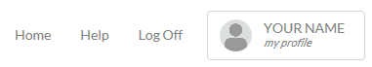

How to Apply
To start an application, click ADD NEW APPLICATION. You will then be asked for the Program Key. If you do not know the Program Key, try the name of the company or organization offering the award.

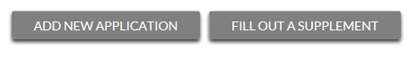

As the applicant, you will not click FILL OUT A SUPPLEMENT. This will be used only by a third party completing a required supplement form for your application. Not every application requires a supplement. Make sure you review the requirements for each application.

Applications View
Each application will have its own box. You will see the program name, application link, application deadline, and Status Button.

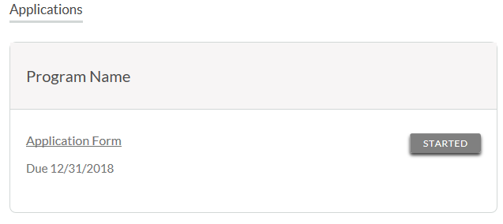
Application Status Buttons
Each application will have one of the following Status Buttons:

If your status button is grey, it means you have not yet clicked the Submit button on the last page of your application. If your status button is orange, it means you have clicked Submit, but you are missing one or more required documents or supplements for that application.

For a details status of each application requirement, click the Status Button.

Detailed Status View
Once you click the Status Button, your detailed status view will appear. Below is an example. Next, we’ll review what each of these statuses mean.

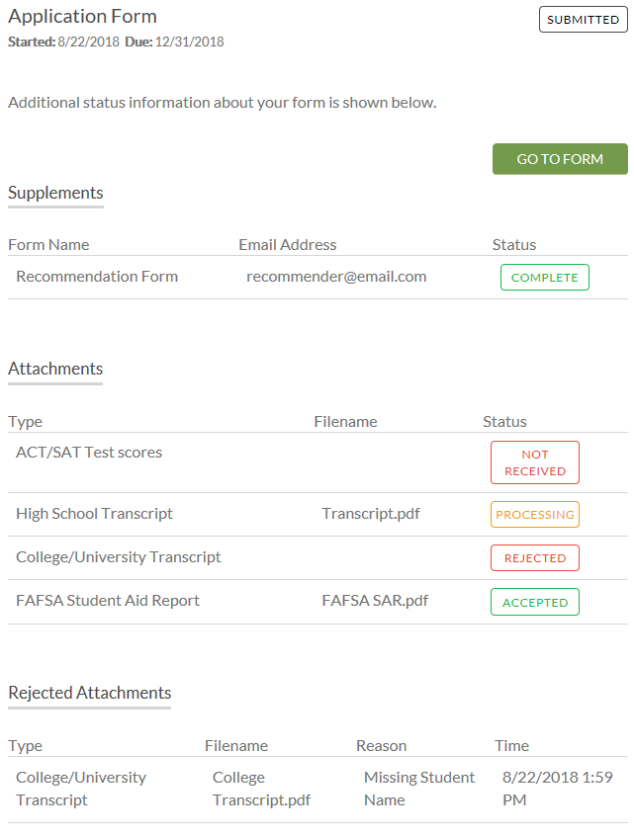
Application Form Section
This top section shows you the date you started the application, application deadline date, status of your form, and provides a button to return to your application.

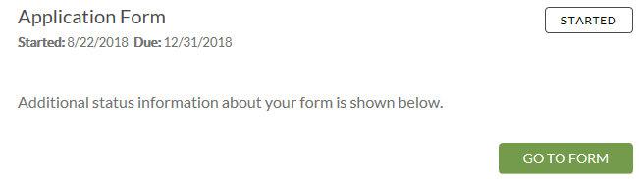

If you have submitted your online application form, the status would read:

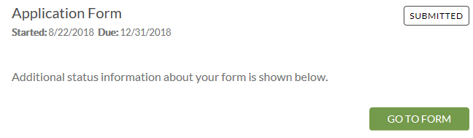

Attachments Section
This section allows you to track the status of each required attachment or supporting document(s) for your application. Not all applications have required attachments. Make sure you review the application requirements for each application.

There are four (4) attachment statuses:

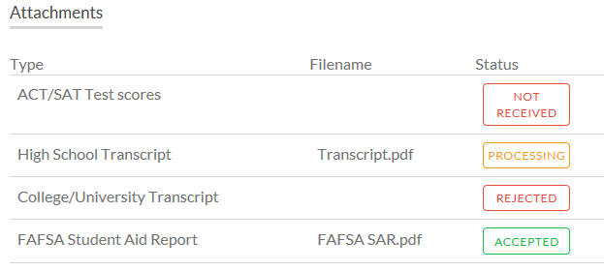

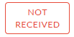
This means you have not yet uploaded this attachment and it is required for your application be considered Complete.

This means your attachment has been uploaded and is currently pending review by ISTS. Attachments are processed within 5-7 business days. All documents uploaded prior to the application deadline will be considered.

This means the document you uploaded was not acceptable. Below the attachment section is the Rejected Attachment section. This will tell you why your attachment was rejected.

This attachment has been reviewed by ISTS and has been verified as meeting all of the requirements needed for that attachment.

Rejected Attachments Section
If you have uploaded a document that does not meet the minimum requirements for the application, your document will be rejected. Your attachment status will read:

You will see the attachment type, file name, the reason for rejection, and the date/time your document was rejected.

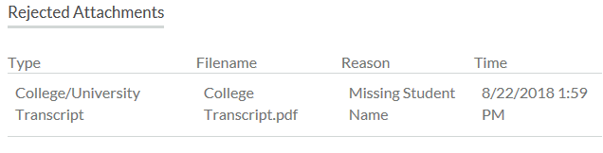

To upload a corrected document, simply click GO TO FORM and upload your document. Make sure you have fixed any of the issues noted in the reason for rejection so that your document is not rejected a second time.

If the application deadline has passed and your application is not Complete because your document was rejected after the application deadline it is important that you contact us immediately so that we can assist you. Most programs allow ISTS to help you correct a rejected document within the 5-7 business day processing time after the deadline. However, this is not guaranteed. Make sure you follow the Upload Instructions within your application to ensure your document meets all minimum criteria.

Contact Information
ISTS office hours are Monday through Friday from 8:00 AM to 5:00 PM Central. Agents are available via live chat and email during these hours. Use the green Help button (as shown below) at the bottom right corner of your screen to contact us. You can even request a call back!

